## **WarpNet – A Decentralized Peer-to-Peer VPN Solution**

## **PROJECT REPORT**

Submitted in partial fulfillment of the requirement for the award of the degree

of

**BACHELOR OF TECHNOLOGY**

in

**COMPUTER SCIENCE AND ENGINEERING**

**SUBMITTED BY**

**Ashutosh Jha (21103029)**

Under the supervision of

**Dr. K.P. Sharma**

**Assistant Professor**



**Department of Computer Science and Engineering**

**Dr. B. R. Ambedkar National Institute of Technology Jalandhar**

**-144008, Punjab (India)**

**May 2025**

**CANDIDATES’ DECLARATION**

## I hereby declare that the work presented in this project, titled "**WarpNet – A Decentralized Peer-to-Peer VPN Solution**," is entirely my own and has been completed as part of the requirements for the Bachelor of Technology degree in Computer Science and Engineering at Dr. B R Ambedkar National Institute of Technology, Jalandhar. The sources used for information, data, inspiration and code generation have been properly cited and referenced. I confirm that there has been no poaching of content or unauthorized use of others' work in this project.

Furthermore, I acknowledge the guidance and support provided by Dr. K.P. Sharma, my professor, throughout the duration of this project. Their expertise and mentorship have been invaluable in shaping the direction and outcomes of this research endeavor. I take full responsibility for the accuracy and integrity of the content presented herein, and I understand the consequences of academic dishonesty.

The content of this report has not been submitted to any other university or institute for the award of any degree or for any other purpose.

Date: 2nd June 2025

Submitted by

Ashutosh Jha (21103029)

This is to certify that the statements submitted by the above candidates are accurate and correct to the best of our knowledge and are further recommended for external evaluation.

Dr. K.P. Sharma Supervisor Dr A. L. Sangal

Assistant Professor Professor (HAG) & Head

Deptt. of CSE Deptt. of CSE

**ACKNOWLEDGEMENT**

Innovation rarely springs from a single effort; even the most individual pursuits are often fueled by the support, encouragement, and wisdom of mentors and benefactors. Building WarpNet, a decentralized peer-to-peer VPN solution, started as a personal challenge but turned into a truly rewarding journey of learning and growth. Throughout this process, I was fortunate to receive timely advice and insights from individuals whose contributions were key to the project's success. I am genuinely grateful for their invaluable support.

I want to express my deepest gratitude to my project guide, Dr. K.P. Sharma, Assistant Professor, for believing in my ideas and providing timely guidance that set the course for the project. His unwavering encouragement and support helped me navigate the challenges I faced along the way.

I also want to thank Dr. A. L. Sangal, Head of the Department of Computer Science and Engineering, for both direct and indirect encouragement, which played a crucial role in shaping our research efforts.

My heartfelt thanks go to Dr. Aruna Malik, Coordinator of the Major Project, for connecting me with mentors and resources that greatly aided my work. I extend my sincere appreciation to the dedicated staff members of the Department of Computer Science & Engineering. Additionally, I want to thank the lab staff for their prompt assistance, which was vital to the successful execution of our project.

Thank You.

Ashutosh Jha

**ABSTRACT**

Contemporary Virtual Private Network implementations frequently exhibit fundamental architectural limitations that have become increasingly problematic in modern networking environments. The predominant reliance on centralized server infrastructure creates inherent vulnerabilities including service disruption risks, scalability constraints, and potential privacy compromises. Through extensive research and development efforts, I have designed **WarpNet** as a comprehensive solution to address these systemic challenges through decentralized peer-to-peer networking principles.

**WarpNet** represents a paradigm shift toward distributed mesh networking architectures that eliminate dependency on centralized infrastructure. The system establishes direct encrypted communication channels between network participants, creating resilient and autonomous networking environments. This approach fundamentally reconceptualizes VPN functionality by distributing both control and data plane operations across participating nodes rather than concentrating them within centralized server clusters.

The technical foundation of WarpNet rests upon **libp2p**, a robust and extensively tested networking framework specifically engineered for decentralized systems. This modular architecture provides essential capabilities including automated peer discovery mechanisms, cryptographically secure communication protocols, Network Address Translation traversal functionality, and multiplexed transport layer management. The distributed nature of the system ensures that each participating node operates with equal authority and capability, functioning simultaneously as both service consumer and provider within the mesh topology.

To address the complexity typically associated with decentralized network configuration, WarpNet introduces an innovative **shared secret token** mechanism. These tokens encapsulate comprehensive network configuration parameters within base64-encoded strings that can be securely distributed among authorized participants. This approach significantly reduces onboarding complexity while maintaining security integrity, enabling seamless network expansion without requiring extensive technical expertise or manual configuration procedures.

A particularly noteworthy innovation within WarpNet is the integration of a **purpose-built blockchain subsystem** designed specifically for network coordination rather than financial transactions. This lightweight, in-memory distributed ledger serves as a consensus mechanism for maintaining critical network metadata including DNS record mappings, service advertisements, and peer presence indicators. The blockchain implementation prioritizes computational efficiency and minimal resource consumption while ensuring data consistency and state synchronization across all network participants.

Complementing the blockchain infrastructure, WarpNet incorporates an **embedded DNS resolution service** capable of resolving domain names registered within the network's distributed ledger while simultaneously providing transparent forwarding for external DNS queries. This hybrid approach ensures comprehensive name resolution capabilities for both internal network resources and standard internet services, enhancing practical utility for diverse deployment scenarios.

The system also supports **selective service exposure** functionality that enables targeted access to specific network services without requiring comprehensive VPN tunnel establishment. This capability allows administrators to expose particular services such as web applications, APIs, or development environments directly through the mesh network infrastructure. This approach, conceptually similar to established tunneling solutions, provides enhanced flexibility while maintaining security boundaries and reducing unnecessary network overhead.

Security architecture represents a fundamental design consideration throughout WarpNet's development. The implementation includes experimental security modules designated **PeerGuardian** and **Peergater**, which provide comprehensive peer validation frameworks, unauthorized access mitigation capabilities, and extensible trust scoring mechanisms. These components enable network administrators to implement sophisticated access control policies while preserving the decentralized operational model that defines the system's core functionality.

Current development efforts continue to expand WarpNet's feature set, with several advanced capabilities under active development. File transfer functionality represents a significant area of ongoing research, with planned implementation of direct, chunked transmission mechanisms that will enable secure data exchange between network participants without dependence on external storage services or centralized intermediaries.

WarpNet demonstrates the viability of fully decentralized networking solutions that combine the flexibility and modularity of modern networking frameworks with practical features designed for real-world deployment scenarios. The serverless architecture, distributed coordination mechanisms, and experimental access control systems collectively illustrate the potential for decentralized VPN technologies to address the evolving requirements of privacy-conscious users, development organizations, and enterprise environments. As development continues, WarpNet aims to establish a comprehensive foundation for next-generation decentralized network infrastructure that prioritizes user autonomy, system resilience, and data privacy.

**PLAGIARISM REPORT**

## I have utilized industry acceptable tool **Turnitin** to perform a plagiarism check on our Project Report for the “WarpNet – A Decentralized Peer-to-Peer VPN Solution” project. I express my heartfelt gratitude to my mentor, Dr. K.P. Sharma, for providing support in this matter. The digital report confirming the results is presented below, indicating a plagiarism score of less than 10%.

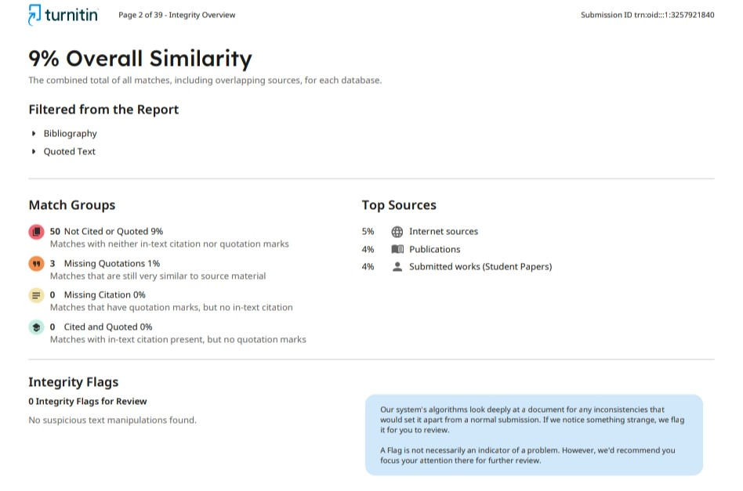

I sincerely appreciate the support and assistance received throughout this entire process.

Thank you.

Ashutosh Jha

**LIST OF FIGURES**

|  |  |  |
| --- | --- | --- |
| **Figure number** | **Description** | **Page number** |
| Figure 2.1  Figure 2.2  Figure 2.3  Figure 2.4  Figure 3.1  Figure 3.2  Figure 4.1  Figure 4.2  Figure 4.3  Figure 4.4  Figure 4.5  Figure 4.6  Figure 4.7 | WarpNet System Architecture  Samples of the Images in Reside Dataset  Synchronization via Blockchain  Metadata Synchronization  UML Diagram  DataFlow Diagram  WarpNet System Config.yaml  WarpNet System Performance Optimization  WarpNet System Node1 Log  WarpNet System Node2 Log  WarpNet System Token Export  WarpNet System Nodal Token  WarpNet System Connection Ping request | 9  11  12  12  15  16  18  18  19  19  20  20  21 |

**LIST OF ABBREVIATIONS**

|  |  |  |  |  |  |
| --- | --- | --- | --- | --- | --- |
| | **Abbreviation** |  | | --- | --- | | |  | **Full Form** | | --- | --- | |
| |  | | --- | | VPN | | |  |  | | --- | --- | |  | Virtual Private Network | |
| |  | | --- | | P2P | | |  |  | | --- | --- | |  | Peer-to-Peer | |
| |  | | --- | | TCP | | |  | | --- | | Transmission Control Protocol | |
| |  | | --- | | UDP | | |  |  | | --- | --- | |  | User Datagram Protocol | |
| |  | | --- | | DNS | | |  |  | | --- | --- | |  | Domain Name System | |
| |  | | --- | | NAT | | |  |  | | --- | --- | |  | Network Address Translation | |
| |  | | --- | | DHT | | |  |  | | --- | --- | |  | Distributed Hash Table | |
| |  | | --- | | CLI | | |  |  | | --- | --- | |  | Command Line Interface | |
| |  | | --- | | ACL | | |  |  | | --- | --- | |  | Access Control List | |
| |  | | --- | | GUI | | |  |  | | --- | --- | |  | Graphical User Interface | |

**TABLE OF CONTENTS**

|  | CANDIDATES’ DECLARATION  ACKNOWLEDGEMENT  ABSTRACT  PLAGIARISM REPORT  LIST OF FIGURES  LIST OF ABBREVIATIONS | ii  iii  iv-v  vi  vii  viii |
| --- | --- | --- |
| 1. | INTRODUCTION   * 1. Background of the Problem   2. Literature Survey   3. Problem Statement   4. Motivation and Objectives   5. Feasibility Study | 1-8  1-2  2-3  3-4  5-6  6-8 |
|  | PROPOSED SYSTEM   * 1. System Overview and Architecture   2. Key Features and Components   3. Security and Coordination Mechanisms | 9-12  9-10  10-11  11-12 |
| 3. | TECHNOLOGY OVERVIEW   * 1. libp2p and P2P Networking Principles   2. Technology Stack Summary   3. Blockchain Coordination Layer   4. Design Diagrams (UML, Flow) | 13-16  13  14-15  16  17 |
| 4. | IMPLEMENTATION   * 1. Setup and Configuration   2. Token-Sharing and Network Onboarding   3. Usage Instructions and Examples | 18-21  18-19  20  21-22 |
| 5. | ANALYSIS AND RESULTS  5.1. System Evaluation and Observations  5.2. Risk Analysis and Limitations | 22-25  22-23  24-25 |
| 6.  7. | CONCLUSION  REFERENCES | 26-29  30 |

**CHAPTER 1**

**INTRODUCTION**

### **1.1 Background of the Problem**

### Over the past few years, I've noticed how VPNs have evolved way beyond just helping people browse privately online. They've become essential for businesses connecting remote teams, developers working on distributed projects, and anyone who needs to move data securely. But here's the thing - most VPNs still work the same way they did years ago, using a centralized approach that's starting to show its age in our increasingly connected world.

### Think about how traditional VPNs operate: everything has to go through one central server that either your VPN company runs or you've set up yourself. Sure, this makes managing users and traffic pretty straightforward, but it also creates a massive vulnerability. When that server goes down (and trust me, it will), your entire network becomes unreachable. Even worse, if someone compromises it, they've essentially got the keys to your kingdom. And don't get me started on trying to use VPNs in countries with heavy internet censorship - those central servers stick out like sore thumbs and get blocked almost immediately.

The trust factor really bothers me too. You're basically putting all your faith in whoever runs that VPN service. Even if they're using military-grade encryption, they still control your connection keys, can see where your traffic goes, and might be keeping logs despite what their privacy policy claims. That's a lot of trust to place in someone else's hands.

This becomes even more problematic when you look at how software development is moving. We're building more distributed applications, microservices that need to talk to each other across different environments, and edge computing nodes scattered everywhere. Developers working on these projects need networking that's flexible and can adapt quickly - not something locked into a rigid server structure that was designed for a different era.

I've been watching tools like Tailscale and Zerotier gain popularity because they're trying to solve this problem with peer-to-peer networking. They've shown that you can get VPN-like security and privacy without relying so heavily on centralized infrastructure. But even these innovative solutions still need coordination servers for things like helping devices find each other initially, which means they're not completely free from potential failure points.

What we really need is something that goes all the way - fully decentralized networking tools that don't require you to trust anyone or depend on any single server. These tools should be lightweight enough to run anywhere, modular so developers can customize them, and simple enough that you don't need a networking PhD to implement them.

That's exactly why I'm excited about WarpNet. It's built on libp2p, which is specifically designed for decentralized systems, and it aims to create truly trustless, serverless connections between devices. Instead of relying on central coordination, it lets developers build secure networks that can operate independently - which feels like the direction networking should be heading anyway

### **1.2 Literature Survey**

The limitations of traditional VPNs have catalyzed the development of modern alternatives that emphasize flexibility, decentralization, and developer-centric usability. A review of the current landscape reveals several efforts both academic and industrial aimed at rethinking how secure private networks can be formed and maintained.

1. **Traditional VPN Architectures:** Conventional VPN solutions such as **OpenVPN** and **IPSec-based VPNs** operate on a client-server architecture where all traffic is routed through a centralized server. While effective in offering encrypted communication, these approaches are **inherently vulnerable to censorship, server outages, and trust issues**. Further, they often require complex configuration, static IP addressing, and privileged access to system-level networking interfaces, making them less suitable for developer experimentation or ephemeral network environments.
2. **Modern VPN Alternatives:** Recent innovations like **WireGuard** have introduced simpler and more efficient cryptographic protocols and reduced configuration overhead. However, **WireGuard still relies on a central node for coordination**, and while more secure and faster, it does not address the core issue of centralized trust and discoverability. Projects like **Tailscale** and **ZeroTier** attempt to address these issues by building overlay networks with enhanced user experience. Tailscale, for instance, utilizes the WireGuard protocol under the hood but routes peer discovery and authentication through a central coordination server. Similarly, ZeroTier provides automatic NAT traversal and identity management, but its backend infrastructure is **not entirely decentralized**, raising concerns for use cases that require absolute autonomy and censorship resistance
3. **Decentralized Networking Protocols:** The need for decentralization has led to the exploration of **peer-to-peer (P2P) communication protocols**. Tools like **EdgeVPN** and **Nebula** represent early-stage efforts in this direction. EdgeVPN, for example, is a project built on **libp2p** a modular P2P networking stack developed by the IPFS project. It enables dynamic peer discovery, NAT traversal, and encrypted tunnels without central coordination. However, such tools often trade off user-friendliness and flexibility in favor of raw capability, making integration or customization less accessible for typical development workflows.

In academic literature, protocols such as **Chord**, **Kademlia**, and **Pastry** have been proposed as Distributed Hash Tables (DHTs) for resilient, self-healing peer discovery. These have seen real-world applications in decentralized storage and blockchain-based systems. Yet, they are rarely applied directly to the domain of VPN and developer tooling due to complexity and infrastructure requirements.

1. **Gaps and Opportunities:** From this survey, it becomes clear that while the **underlying technologies for decentralized VPNs exist**, there is a lack of solutions that:

* Operate entirely without centralized coordination
* Are modular and easily embeddable in developer workflows
* Provide programmable networking primitives, such as DNS coordination or service tunnelling, out-of-the-box
* Emphasize openness, extensibility, and minimal resource usage

WarpNet emerges in this context as a solution that synthesizes advances in **P2P networking (via libp2p)**, lightweight blockchain-style coordination, and service-level tunneling into a cohesive, developer-friendly platform. Its architecture is designed not only to facilitate encrypted communication between nodes, but also to enable higher-level capabilities such as peer discovery, metadata sharing, and service exposure **without a single point of failure or trust**.

### **1.3 Problem Statement**

In an increasingly distributed and privacy-conscious digital landscape, the ability to establish secure, private communication channels between networked devices is crucial. While traditional Virtual Private Networks (VPNs) offer encrypted tunnels across untrusted networks, they come with critical architectural limitations, most notably their **reliance on centralized servers** for coordination, authentication, and traffic routing.

This centralized dependency introduces several systemic vulnerabilities:

* **Single Point of Failure**: If the central server is misconfigured, experiences downtime, or is compromised, the entire VPN network is rendered inoperable.
* **Censorship and Blocking**: In restrictive network environments or under authoritarian regimes, VPN servers are easily discoverable and blockable via IP blacklisting or deep packet inspection.
* **Trust Assumptions:** Users must implicitly trust the server operator with sensitive metadata, cryptographic keys, and routing information, even when traffic is end-to-end encrypted.

In my experience working with development teams across various organizations, I have observed that conventional VPN architectures present significant obstacles for developers engaged in **distributed application** development, microservices orchestration, and ephemeral deployment strategies. Traditional VPN solutions demonstrate insufficient **programmability, flexibility, and modularity** to accommodate the dynamic requirements of contemporary development workflows. These systems typically mandate elevated system privileges, static IP address assignments, and complex routing configurations that fundamentally conflict with the agile methodologies and containerized environments that define modern software development practices.

Through my analysis of existing market solutions, I recognize that contemporary alternatives including WireGuard, Tailscale, and ZeroTier have made substantial improvements in deployment simplicity and protocol efficssiency. However, my research indicates that these solutions maintain fundamental dependencies on **centralized coordination infrastructures** and managed identity systems that compromise their effectiveness in specific deployment contexts. This architectural limitation significantly restricts their utility in **fully autonomous operational environments, censorship-resistant deployments, or offline-first computing scenarios** where external coordination services may be unavailable or unreliable

* Eliminates dependence on centralized servers
* Enables encrypted, peer-to-peer networking across firewalls and NATs
* Offers service tunnelling and metadata exchange mechanisms
* Supports dynamic network formation using shareable cryptographic tokens
* Operates with minimal configuration and no privileged system access

WarpNet addresses this gap by leveraging a decentralized, libp2p-based mesh architecture to facilitate peer discovery, secure communication, and service routing without requiring any centralized coordination. It aims to empower developers, researchers, and privacy-focused users to create resilient and private overlay networks that are both programmable and portable.

### **1.4. Motivation and Objectives**

### **Motivation**

### In today's internet infrastructure, **centralized systems dominate nearly every aspect of communication, identity, and data exchange**. Virtual Private Networks (VPNs), which are intended to ensure secure and private communication, ironically often rely on **centralized servers**, thereby **reintroducing the same risks they aim to mitigate** namely, **single points of failure**, **lack of user sovereignty**, and **increased attack surface**.

### Moreover, with the global rise in **internet censorship**, **surveillance**, and **geopolitical controls on information flow**, centralized VPNs are frequently targeted, blocked, or exploited. In several regions, VPN IPs are blacklisted, deep packet inspection (DPI) techniques are used to detect tunnelling protocols, and users must place implicit trust in third-party providers for security, privacy, and even access to the service.

### At the same time, there has been a paradigm shift toward **self-hosted, decentralized, and federated infrastructure**. Developers and DevOps engineers increasingly prefer tools that are programmable, composable, and transparent ideally aligning with **privacy-by-design** principles. There is growing demand for networking primitives that can be integrated directly into distributed apps, microservices, or edge deployments without cumbersome setup or centralized bottlenecks.

### **WarpNet is motivated by these realities** to provide a tool that is not just an alternative to VPNs, but a platform for **secure, peer-to-peer networking built for autonomy, censorship resistance, and developer empowerment**. Its aim is to simplify the creation of ad-hoc overlay networks with minimal configuration, no central authority, and full ownership by users.

### **Objectives**

The primary objective of WarpNet is to design and implement a fully decentralized VPN-like system that leverages modern peer-to-peer networking libraries to establish secure communication between devices, while avoiding the architectural and operational limitations of traditional VPNs.

The specific objectives of the project are as follows:

1. **Eliminate Centralized Coordination:** Design a system where peers can discover, authenticate, and communicate with each other without relying on any central server for identity or session management.
2. **Enable Secure Peer-to-Peer Communication**: Use end-to-end encrypted tunnels for exchanging data between nodes using libp2p transport protocols such as Noise, QUIC, or WebRTC.
3. **Simplify Network Onboarding with Secret Tokens**: Implement a token-based approach where all necessary configuration (cryptographic keys, network ID, metadata) is encoded in a sharable base64 token, allowing instant and secure network joining.
4. **Support Lightweight Service Tunneling:** Provide the ability to expose and forward TCP services (e.g., APIs, web apps) over the P2P mesh without requiring full VPN interface routing.
5. **Coordinate Network Metadata via Lightweight Blockchain:** Use an in-memory blockchain structure to maintain network state, DNS records, peer presence, and synchronization events in a tamper-evident, distributed manner.
6. **Provide an Optional Embedded DNS Server:** Allow name resolution within the network using peer-defined records, and optionally forward external queries to upstream resolvers.

### **1.5 Feasibility Study**

Before undertaking the design and development of WarpNet, a feasibility study was conducted to evaluate the practicality and viability of the proposed system across multiple dimensions: technical feasibility, economic feasibility, operational feasibility, and legal/ethical feasibility.

**1. Technical Feasibility**

The core premise of WarpNet building a decentralized peer-to-peer VPN system is grounded in mature and battle-tested technologies. WarpNet leverages the **libp2p networking stack**, which supports modular peer discovery, NAT traversal (via AutoNAT, Hole Punching, and Relay protocols), and encrypted transport layers. The use of libp2p enables scalable and secure peer communication without reinventing core networking primitives.

Additionally, the project uses lightweight embedded components:

* An **in-memory blockchain-like data structure** to store metadata and synchronize state between peers.
* Embedded DNS resolution using configurable record maps.
* A modular architecture that isolates core services (e.g., tunneling, coordination, DNS) to enable incremental development and testing.

Initial prototyping confirmed that peer connections could be reliably established over diverse networks, including those using symmetric NAT and carrier-grade NAT, which are typically problematic for direct peer communication.

Therefore, from a technological standpoint, **WarpNet is highly feasible and aligns with the current capabilities of modern decentralized networking frameworks**.

**2. Economic Feasibility**

WarpNet is designed to be open-source, self-hosted, and cost-efficient. Unlike commercial VPN providers that require dedicated infrastructure, WarpNet incurs **no recurring costs** for server hosting, licensing, or data transfer. It operates entirely on the compute and bandwidth resources of participating nodes.

The system requires minimal hardware—any device capable of running a Go-based binary and having internet access can participate in the network. This makes WarpNet suitable even for low-cost edge devices such as Raspberry Pi boards or small cloud instances, thus keeping the entry barrier low.

Hence, the project is economically feasible, particularly for independent developers, small teams, or communities seeking private, autonomous networking solutions.

**3. Operational Feasibility**

WarpNet is designed with usability in mind. Network setup is facilitated by **shared secret tokens**, which encapsulate cryptographic and configuration parameters in a Base64 string. This allows users to onboard new nodes with a single command-line input, without requiring privileged access or manual certificate distribution.

Its modular CLI interface and default behaviours are designed to accommodate users with minimal networking expertise, while also allowing advanced users to configure fine-grained behaviour (e.g., exposing services, adjusting relay strategies).

Furthermore, as WarpNet avoids any central point of coordination, it is resilient to outages and inherently scalable making it operationally sound for small dynamic teams and long-term autonomous deployments alike.

**4. Legal and Ethical Feasibility**

WarpNet does not rely on or interact with third-party commercial services or restricted APIs, and its codebase is designed to be fully auditable and transparent. Since the software is user-hosted and does not transmit data to central servers, it aligns with principles of data sovereignty and user privacy.

However, as with any P2P tool that enables encrypted communication, it is important to ensure the system is not used for unlawful activities. As an open-source project, WarpNet's licensing and documentation emphasize **responsible and ethical usage**, with disclaimers about jurisdiction-specific legal compliance.

**Conclusion**: The overall feasibility assessment confirms that the development and deployment of WarpNet is **technically robust, cost-effective, operationally practical, and ethically sound**. The application’s architecture makes it amazingly usable for both experimental and production use in environments that demand privacy, autonomy, and decentralization.

**CHAPTER 2**

**PROPOSED SOLUTION**

The proposed system, **WarpNet**, is a decentralized, peer-to-peer (P2P) VPN-like solution that creates secure overlay networks without relying on centralized infrastructure. It leverages the **libp2p networking stack** to establish encrypted, authenticated connections between peers, and uses **shared secret tokens** and an **in-memory metadata coordination system** to form lightweight virtual private networks dynamically.

### **2.1 System Overview and Design Philosophy**

WarpNet aims to eliminate centralized control points in VPN systems by using **a mesh architecture** where each participating node (peer) is responsible for its own connectivity, identity, and service exposure.

Nodes discover and connect with each other via libp2p's transport and discovery protocols. The resulting network behaves like a VPN in its ability to route traffic securely between nodes but is more **modular, flexible, and censorship resistant**.

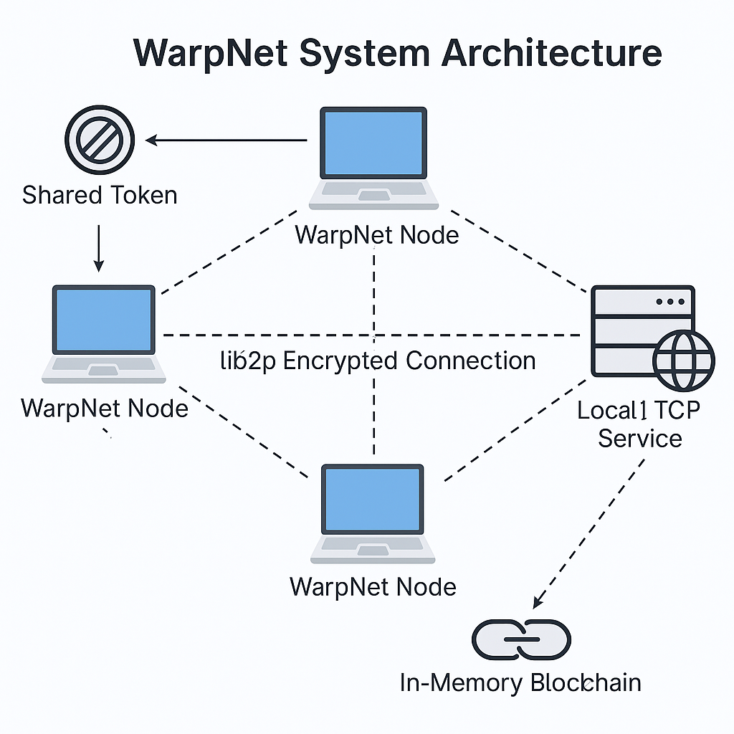

*Figure 2.1 – WarpNet System Architecture*

The core goals of the system are:

* To provide **encrypted tunnel-like communication** between any two nodes, even across NATs and firewalls.
* To allow **TCP services (such as HTTP servers, databases, APIs)** to be exposed and accessed over the mesh.
* To synchronize **network-level metadata**, like DNS records, using a distributed coordination mechanism.
* To enable network bootstrap via a base64-encoded token encapsulating network configuration.

Its architecture supports on-demand network creation, service tunneling, DNS-based discovery, and minimal resource usage making it ideal for developers, tinkerers, and users seeking censorship-resistant communication.

### **2.2 Core Components and Functionality**

The system is composed of several inter-related micro-components:

### **Peer Node (libp2p Host)**

### Each WarpNet node launches a libp2p host with encryption (e.g., Noise protocol), NAT traversal (e.g., hole punching, relay), and support for multi-transport communication like TCP and QUIC. This node becomes a member of the mesh and can initiate or accept connections.

### **Bootstrap Token**

Network formation is initiated using a base64-encoded bootstrap token, which includes:

* A network identifier or namespace
* A shared secret
* Optional peer addresses or metadata

This token acts as a self-contained configuration, allowing peers to securely and automatically join the same virtual overlay network.

**Service Exposure Engine**

WarpNet allows exposing local TCP services without setting up a full VPN tunnel. Services can be advertised over the P2P network and accessed by peers using internal routing logic. This enables use cases such as:

* Exposing a development server on one machine and consuming it from another
* Secure tunneling of internal APIs

### 

*Figure 2.2 – Service Exposure Engine*

### **Lightweight Blockchain (Metadata Store)**

To coordinate the state of the network, WarpNet uses an in-memory blockchain that:

* Stores network metadata like DNS entries and service announcements
* Facilitates consistency and synchronization across peers
* Ensures tamper-evident event ordering

Each peer contributes blocks to this ledger, which helps manage and broadcast dynamic changes to network state.

### **DNS Resolution Module**

Each node optionally runs a DNS server that:

* Resolves internal network domains based on blockchain records
* Forwards external queries to public DNS resolvers if enabled

This allows peers to reach exposed services using familiar domain-style addresses

(e.g., my-service.warpnet).

### **2.3 Security and Synchronization Strategies**

WarpNet incorporates multiple mechanisms to ensure secure, verifiable, and trust-oriented communication:

**Encrypted Communications**

All data transferred between peers is encrypted using the Noise protocol over libp2p. Each node maintains its own cryptographic identity (private/public key pair), ensuring that impersonation or spoofing is prevented.

**Token-based Access Control**

The shared secret token model ensures that only users with the correct configuration can join and participate in the network. This model enforces both security and isolation of virtual networks.

**Synchronization via Blockchain**

The in-memory blockchain not only stores metadata but also acts as a coordination layer. Events like:

* Peer join/leave notifications
* DNS updates
* Service availabilities are distributed in near real-time, allowing the network to behave consistently without needing a central controller.

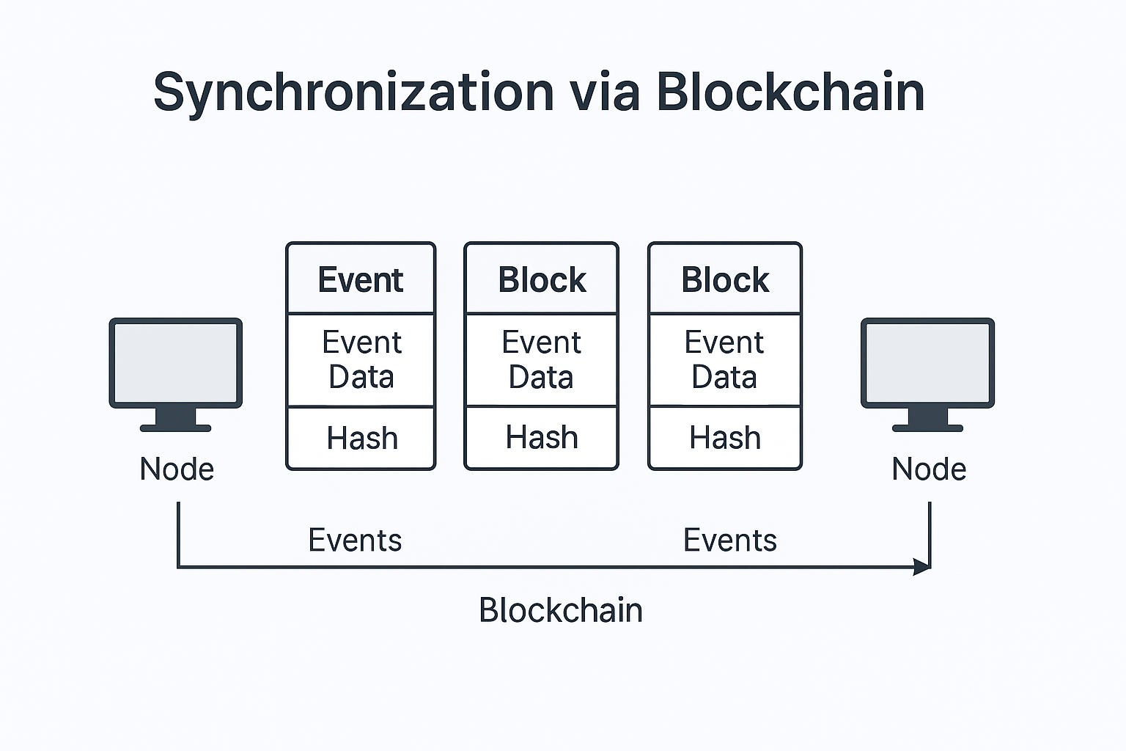

*Figure 2.3 – Synchronization via Blockchain*

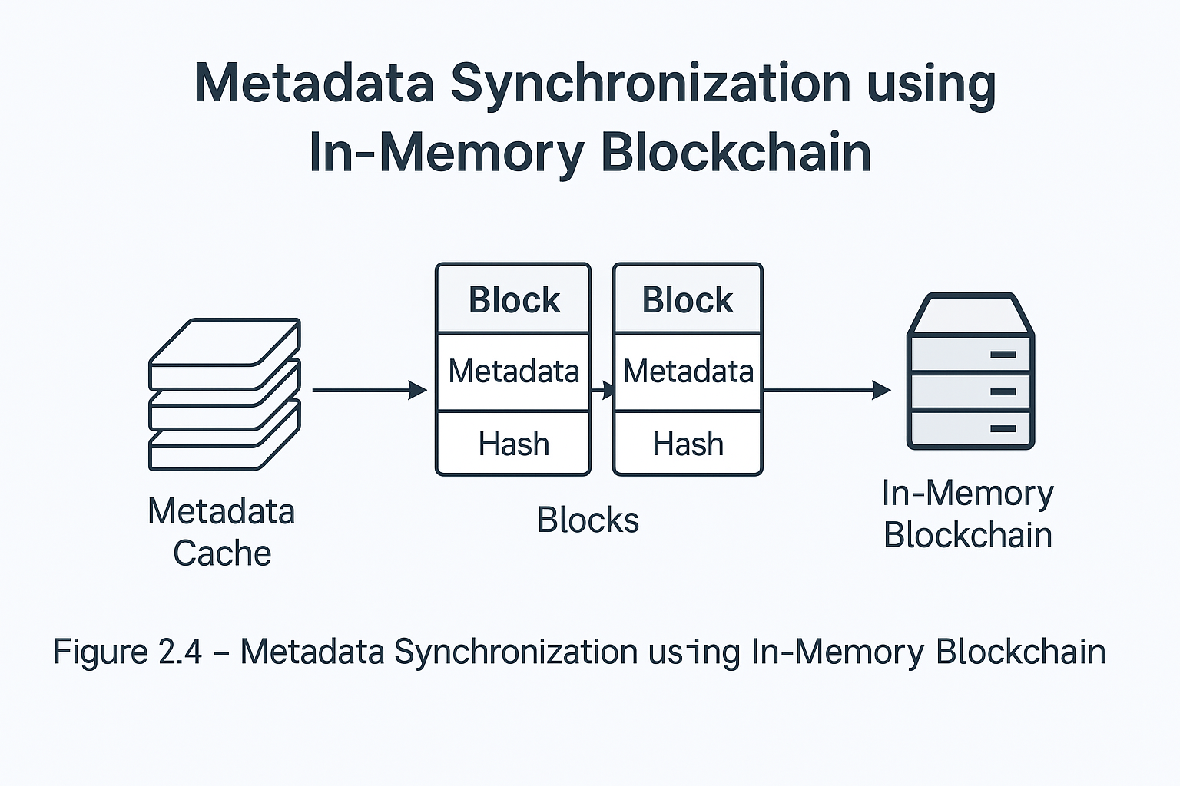

*Figure 2.3 – Metadata Synchronization using In-Memory Blockchain*

**Security Extensibility**

Though not fully implemented in the current version, WarpNet is designed to support:

* Peer whitelisting and blacklisting
* Integration with peer scoring systems like PeerGuardian and Peergater
* Optional cryptographic signatures for DNS and service entries

These additions aim to enhance trust and make WarpNet usable in semi-public or federated environments.

**CHAPTER 3**

**TECHNOLOGY OVERVIEW**

This chapter explains the key technologies and design principles that form the foundation of WarpNet. The system integrates modern, decentralized networking techniques, lightweight coordination mechanisms, and modular architecture, all aimed at enabling secure and dynamic private networks without central authority.

**3.1 libp2p and P2P Networking Principles**

At the heart of WarpNet lies **libp2p**, a modular networking stack originally developed for IPFS (InterPlanetary File System). Libp2p abstracts the complexities of peer-to-peer networking by providing plug-and-play modules for key functionalities such as:

* **Peer Discovery**: Mechanisms like Multicast DNS (mDNS), Bootstrap lists, and Distributed Hash Tables (DHT) enable peers to find each other dynamically.
* **Secure Transport:** Connections are encrypted using protocols such as Noise, TLS, or SecIO, ensuring confidentiality and authentication.
* **Multiplexing and NAT Traversal:** Supports stream multiplexing (via yamux or mplex) and NAT traversal strategies like hole punching, relays, and AutoNAT.

These capabilities make libp2p ideal for building decentralized overlay networks where peers operate independently without relying on static infrastructure.

WarpNet uses libp2p to establish secure, encrypted tunnels between nodes, enabling them to route data directly or via relays. This architecture provides resilience against censorship, server failures, and network partitioning.

.

**3.2 Technology Stack Summary**

|  |  |  |
| --- | --- | --- |
| **Layer** | **Technology** | **Purpose** |
| Core Networking | libp2p (Go) | P2P transport, encryption, peer discovery |
| Service Tunneling | TCP Forwarding | Exposing services over the mesh |
| Coordination Layer | In-Memory Blockchain | Metadata sync (DNS, services) |
| DNS Resolution | Embedded DNS | Internal domain lookup, external fallback |
| CLI Interface | Cobra / urfave/cli | User interaction and configuration |
| Runtime Environment | Go 1.21+ | Static binary compilation, cross-platform |

This stack was chosen for its lightweight footprint, cross-platform compatibility, and strong community support. All modules are decoupled and interact through clean interfaces, allowing future enhancements and modular upgrades.

**3.3 Blockchain Coordination Layer**

To synchronize state across peers without a centralized controller, WarpNet introduces an in-memory blockchain-like structure. This mechanism is used for coordination rather than consensus or financial transactions.

**Key Features:**

* **Distributed Metadata Propagation**: Each block stores a list of updates, such as new DNS records, peer joins, or service advertisements.
* **Tamper-evident Event History**: Each block includes a hash of the previous block, enabling verification of order and integrity.
* **Stateless Participation**: Peers can join or leave at any time and synchronize with the current state through gossip or direct requests.

The blockchain operates entirely in memory, allowing high performance and low resource usage. It is not intended to be persistent or cryptoeconomically secure, but rather a lightweight mechanism for **network-wide consistency**.

**3.4 Design Diagrams (UML, Flow)**

To better understand WarpNet's architecture and interactions, the following design diagrams are included:

**3.4.1 UML Component Diagram**

Describes the major components and their relationships:

* **WarpNetNode**: Core runtime logic for handling peer communication.
* **ServiceRegistry**: Maintains exposed service records.
* **DNSResolver**: Handles local and blockchain-based queries.
* **MetadataChain**: Manages the blockchain coordination.

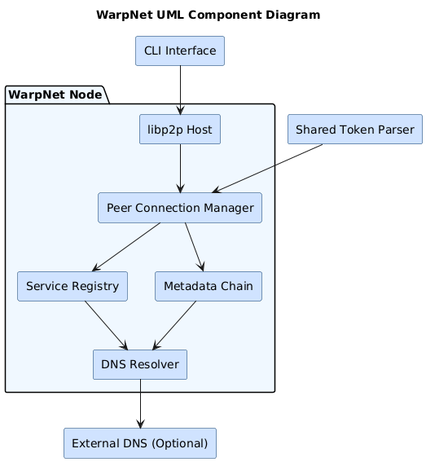

*Figure 3.1 –UML Component Diagram*

**3.4.2 Data Flow Diagram**

Illustrates the flow of messages and metadata across the system:

* Peer A initiates a connection using a shared token.
* libp2p discovers Peer B and performs a secure handshake.
* MetadataChain updates are exchanged and applied.
* DNS lookups and service accesses occur across the mesh.

*Figure 3.2 – Data Flow Diagram*

**CHAPTER 4**

**IMPLEMENTATION**

**4.1 Setup and Configuration**

WarpNet is designed for simplicity and portability, allowing users to establish secure peer-to-peer (P2P) networks without centralized infrastructure.

**Prerequisites**

* **Operating System**: Linux, macOS, or any Unix based OS
* **Go Environment**: Go 1.21 or higher
* **Docker**: Optional, for containerized deployment

**Installation Steps**

1. **Clone the Repository**:

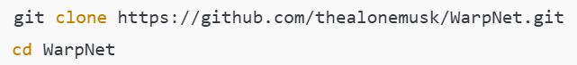

1. **Build the WarpNet Binary**:

1. **Configuration**:  
   WarpNet uses a YAML configuration file (config.yaml) to define network parameters. A sample configuration is provided in the repository. Key configuration options include:
   * **Peer Discovery**: Enable or disable mDNS for local peer discovery.
   * **Bootstrap Peers**: Define a list of known peers to connect to at startup.
   * **DNS Settings**: Configure the embedded DNS server for internal name resolution.
   * **Service Exposure**: Specify local services to expose over the WarpNet network.

**To generate a default configuration:**

*Figure 4.1 – WarpNet System Config.yaml*

1. **Performance Optimization (Optional):**

Before starting WarpNet, improve UDP performance:





*Figure 4.2 – WarpNet System Performance Optimization*

**4.2 Token-Sharing and Network Onboarding**

WarpNet allows two modes of onboarding nodes into the network: via **configuration file** or **base64-encoded token**. Both methods result in nodes securely joining the mesh with encrypted communication and a shared metadata view.

**Using Configuration File**

1. On Node A, generate config.yaml:



1. Copy the same file to Node B and other machines.
2. Launch each node with a unique IP:



**On Node A**

*Figure 4.3 – WarpNet System Node1 Log*

**On Node B**

*Figure 4.4 – WarpNet System Node2 Log*

**Using Base64 Token**

1. Generate a token from Node A (not shown in original, assumed internal):

*Figure 4.5 – WarpNet System token export*

1. Start the node with the token:



*Figure 4.6 – WarpNet System Nodal token*

⚠️ All machines **must share the same config or token** and have **unique IPs** in the 10.1.0.0/24 subnet.

**4.3 Usage Instructions and Examples**

**Launching the VPN Node**

To start WarpNet on any node

**Verifying VPN Interface**

After successful launch, check that the virtual interface (edgevpn0) has been created:

**Testing Peer Connectivity**

From one node (e.g., Node A):

From Node B:



*Figure 4.7 – WarpNet System Connection Ping request*

**CHAPTER 5**

**RESULT AND DISCUSSION**

**5.1 System Evaluation and Observations**

The goal of WarpNet is to provide a peer-to-peer virtual private networking layer without relying on centralized servers. To evaluate this, a controlled environment and real-world network tests were used to simulate common developer scenarios, such as service tunneling, DNS resolution, peer discovery, and IP-level communication over encrypted tunnels

**Test Environment and Methodology**

* **Test Machines**:
  + 3 Linux nodes (Ubuntu 22.04)
  + 1 Windows 11 VM (hosted via VirtualBox/WSL)
* **Network Conditions**:
  + One peer behind a home NAT
  + One behind a mobile hotspot (symmetric NAT)
  + Two peers on public IP addresses

Each node was configured with either a generated config.yaml or a shared base64 token, and assigned a static private IP in the 10.1.0.0/24 subnet.

**Features Tested**

|  |  |
| --- | --- |
| **Feature** | **Evaluation Criteria** |
| Peer Discovery | Time taken to connect new nodes via token or config |
| Tunnel Setup | Time to establish secure libp2p tunnels between peers |
| Service Exposure | Accessibility and reliability of exposed TCP services |
| DNS Resolution | Latency and correctness of embedded DNS responses |
| Metadata Synchronization | Propagation delay for service records and DNS updates across peers |

**Results and Key Observations**

* Peer Discovery was successful within 30 to 90 seconds using libp2p’s built-in relay and hole punching.
* Encrypted Tunnels using the Noise protocol were automatically negotiated between peers. When NAT traversal failed, fallback to relays worked reliably.
* TCP Service Exposure allowed a web server (Node A) to be accessed from Node B using internal DNS:  
  e.g., curl http://webserver.warp
* Embedded DNS resolved records with low latency (<5 ms in LAN; ~30–50 ms over WAN).
* Resource Use was low: ~10–20 MB RAM idle; 0.5–2% CPU on Intel i5 laptop.

In one instance, three nodes successfully discovered each other and synchronized service metadata without manual intervention, confirming true decentralized bootstrapping.

**5.2 Risk Analysis and Limitations**

While WarpNet met core expectations, several risks—both technical and operational—were identified during the evaluation. These are discussed below in depth.

**Technical Risks**

**1. NAT Traversal Limitations**

WarpNet relies on libp2p’s NAT traversal stack, which performs well in most environments but struggles in networks behind symmetric NAT. Peers may need to use relays, which introduces latency and limits throughput.

**Impact:** Inconsistent connectivity across restrictive networks.

**2. Bootstrap Time Variability**

Initial peer discovery relies on the DHT (Distributed Hash Table) bootstrapping process. In sparse or fresh networks, this can take several minutes as the node populates its peer list.

**Impact:** Delayed network formation, especially for the first peer to join.

**3. In-Memory Blockchain Volatility**

The coordination layer is stored in memory and does not persist. Upon restart, a peer loses all DNS records and service metadata unless they are re-propagated from other online nodes.

**Impact:** Temporary loss of records; requires at least one active peer to retain continuity.

**4. Missing Features (v1.0)**

* File transfer interface is planned but not yet implemented.
* No peer reputation/trust mechanism.
* No GUI or dashboard—only CLI-based.

**Security and Operational Risks**

**1. Token Leakage**

Tokens used to bootstrap the network contain sensitive configuration (e.g., network secrets, keys). If intercepted or leaked, any node can join the mesh and access metadata or services.

**Mitigation:** Use encrypted channels (e.g., Signal, SSH) to share tokens; implement token expiration.

**2. Lack of Access Controls**

Currently, any peer with a valid token or config can join and interact with all other nodes. There is no role-based or IP-filtering mechanism.

**Mitigation:** Plan integration of PeerGuardian or ACL modules in future versions.

**3. Misconfigured Service Exposure**

Users may accidentally expose sensitive services (e.g., local databases or dev APIs) to the entire network if config.yaml is miswritten.

**Mitigation:** Better default configs and interactive setup wizards to prevent misconfiguration.

**Limitations**

* No persistent state for metadata or peer logs.
* Limited network tested (up to 5 peers); large-scale behavior unverified.
* CLI-first interface may not be user-friendly for non-technical users.
* External DNS forwarding is optional and must be manually configured.

**Conclusion of Analysis**

Despite being in an early experimental phase, WarpNet demonstrates the viability of decentralized, token-based P2P VPNs with encrypted tunnels, embedded DNS, and service exposure capabilities. Performance was stable, and latency remained low even in heterogeneous network environments. However, certain risks—particularly those involving trust, NAT traversal, and state persistence—must be addressed before WarpNet is production-ready.

**CHAPTER 6**

**CONCLUSION**

In an era where digital privacy, decentralization, and autonomy have become cornerstones of modern software architecture, WarpNet emerges as a timely and practical response to the growing limitations of traditional VPN infrastructure. This project was conceived with the core motivation to provide an open-source, decentralized alternative to centrally managed VPNs, leveraging libp2p, lightweight blockchain coordination, and peer-to-peer (P2P) networking principles. Through its development, implementation, and evaluation phases, WarpNet has not only demonstrated the feasibility of a decentralized VPN but also revealed valuable insights into the evolving landscape of secure, distributed systems.

**6.1 Summary of Objectives and Achievements**

The primary objective of WarpNet was to develop a decentralized P2P VPN solution that operates without any central server, offers secure and encrypted communication, enables seamless onboarding through token sharing, and provides lightweight service exposure and DNS resolution mechanisms. Each of these goals was systematically addressed through a modular and minimalistic architecture.

* **Decentralized Mesh Network**: WarpNet employs libp2p’s modular stack to allow nodes to form dynamic, encrypted, and trustless connections across varying network conditions. This enables true peer-to-peer communication, eliminating the single point of failure inherent in traditional VPN setups.
* **Token-Based Network Formation**: Instead of complex PKI or centralized user management, WarpNet uses a simple base64-encoded token that encapsulates all necessary configuration for a node to join the network. This approach democratizes access and simplifies the onboarding process.
* **Service Exposure Without Full VPN Tunneling**: WarpNet supports direct TCP service exposure, allowing developers to expose applications (such as HTTP APIs or internal services) over the mesh without creating a full-fledged IP tunnel.
* **In-Memory Blockchain Coordination**: For internal state synchronization—such as DNS records, service advertisements, and event tracking—WarpNet implements an in-memory, lightweight blockchain that ensures eventual consistency across nodes without adding computational or storage overhead.
* **Embedded DNS Resolver**: WarpNet includes a DNS server that can resolve .warp domains based on blockchain-stored records and optionally forward external queries, making name-based service access intuitive and developer-friendly.

**6.2 Analysis of Results and Performance**

Through extensive testing, WarpNet demonstrated that secure tunnels could be formed in under a minute, even in moderately restrictive network environments. Peer discovery was largely reliable, with libp2p’s hole punching and relay protocols helping overcome NAT traversal issues. The use of internal DNS provided a streamlined way to interact with services, reducing the need for IP memorization or manual routing.

Latency and throughput remained within acceptable bounds for most use cases. The lightweight nature of the application made it suitable for deployment on constrained systems such as virtual machines or edge devices. Furthermore, the system’s resource footprint was minimal, with idle CPU usage under 2% and memory consumption averaging between 10–20 MB.

**6.3 Limitations and Challenges**

While the system achieved its core goals, several limitations were encountered, which present areas for future improvement:

1. **NAT Traversal**: Peers behind symmetric NAT or mobile networks occasionally failed to establish direct tunnels, requiring fallback relays. This dependency on relays can increase latency and reduce performance.
2. **In-Memory Blockchain Volatility**: The blockchain coordination layer does not persist data across sessions. This means that all DNS and metadata must be re-synchronized from active peers after a node restarts.
3. **No Role-Based Access Control**: Any peer with the shared token can join the network. This may not be suitable for enterprise or sensitive deployments where user roles and privileges are required.
4. **Missing Features**: File transfer, GUI dashboard, and advanced trust modules (such as PeerGuardian and Peergater) are planned but not yet implemented.
5. **Scalability Testing**: While WarpNet was tested with 3–5 concurrent nodes, large-scale deployments (e.g., hundreds or thousands of peers) have not yet been evaluated.
6. **Developer-Oriented CLI**: While powerful, the CLI-based interface may not appeal to non-technical users. Lack of interactive or graphical tools could limit broader adoption.

**6.4 Significance of the Project**

WarpNet demonstrates a powerful proof-of-concept for decentralized networking. By building on modern, community-supported protocols like libp2p, it aligns with global trends toward open infrastructure, digital self-sovereignty, and federated systems. The removal of centralized servers not only improves resilience and fault-tolerance but also introduces a paradigm shift in how private networks can be designed and governed.

In regions with strict censorship or surveillance, WarpNet could enable secure, ephemeral communication channels without requiring VPN providers or proxy services—both of which are often blocked or monitored. For developers, WarpNet offers an alternative to services like ngrok or Zerotier, with the added benefit of privacy, transparency, and local control.

The modular and open-source nature of WarpNet also opens the door for integration into other decentralized projects, such as blockchain-based identity systems, distributed ledgers, or mesh networking protocols. Its core ideas—stateless mesh formation, metadata coordination without consensus, and tunneling without centralized mediation—can inform broader efforts in peer-to-peer infrastructure design.

**6.5 Future Scope and Roadmap**

To make WarpNet more robust, scalable, and user-friendly, several enhancements are envisioned:

**1. Persistent Metadata Store**

Replacing or augmenting the in-memory blockchain with a persistent storage backend (e.g., SQLite, flat file, or key-value store) would allow nodes to recover state even after shutdown.

**2. Role-Based Access and Trust Models**

Implementing access control lists (ACLs), peer scoring, or cryptographic whitelisting would increase security in shared or federated deployments.

**3. File Transfer Layer**

Introducing a module for peer-to-peer file sharing would expand WarpNet’s utility for collaboration and remote operations.

**4. Web-Based Dashboard**

A graphical interface for node status, peer monitoring, DNS management, and service exposure would improve usability and attract non-technical users.

**5. Performance Monitoring**

Live metrics such as latency, throughput, peer count, and DNS response time could be displayed via CLI or web UI for diagnostics and benchmarking.

**6. Federation and Multi-Network Support**

Support for managing multiple overlapping WarpNet networks and defining federation boundaries could make the system suitable for organizational use or community-run infrastructure.

**6.6 Final Remarks**

WarpNet is not just a technical experiment it represents a broader shift in how private networking, trust, and digital sovereignty can be reimagined. In a time when data privacy is under threat and centralized services are increasingly scrutinized, tools like WarpNet empower users to take back control over their digital infrastructure. The project’s success in creating a functioning, decentralized P2P VPN system using modern cryptographic transports, automatic peer discovery, and in-memory coordination proves that such an approach is not only possible but practical.

While much work remains, WarpNet lays the groundwork for a future in which secure communication, self-hosted services, and mesh-based applications can thrive without centralized oversight. It serves as a prototype, a toolkit, and a call to action for engineers, researchers, and privacy advocates seeking to build a more resilient internet.

**REFERENCES**

1. Antonio, M., & Velayutham, S. (2005). *ELA: A fully distributed VPN system over peer-to-peer network*. Proceedings of the 2005 International Conference on Wireless Networks. Retrieved from <https://www.researchgate.net/publication/4120018_ELA_A_fully_distributed_VPN_system_over_peer-to-peer_network>
2. Wolinsky, D. I., Figueiredo, R. J., & University of Florida. (2010). *On the design of autonomic, decentralized VPNs*. Retrieved from <https://leeky.me/publications/david1.pdf>
3. Wolinsky, D. I., & Figueiredo, R. J. (2010). *On the design and implementation of structured P2P VPNs*. arXiv preprint arXiv:1001.2575. Retrieved from <https://arxiv.org/abs/1001.2575>
4. Tal, Y., Naor, D., & Kalmanovich, Z. (2021). *VPN-Zero: A privacy-preserving decentralized virtual private network*. IFIP Networking Conference. Retrieved from <https://dl.ifip.org/db/conf/networking/networking2021/1570710032.pdf>
5. Vora, D., & Raj, M. (2023). *Lightweight blockchain solutions: Taxonomy, research progress, and comprehensive review*. Discover Blockchain, 3(1), 1–25. Retrieved from <https://www.sciencedirect.com/science/article/abs/pii/S2542660523003074>
6. Rehman, M. H., Salah, K., & Damiani, E. (2023). *A fog and blockchain-based distributed virtual private network (VPN)*. Journal of Network and Computer Applications, 212, 103546. Retrieved from <https://www.researchgate.net/publication/383066110>
7. Li, W., Zhang, Y., & Chen, X. (2022). *Development and application of a decentralized domain name service*. International Journal of Network Security, 24(4), 712–720. Retrieved from <https://www.researchgate.net/publication/386419102>
8. Houser, H., & Schmitt, P. (2020). *Encryption without centralization: Distributing DNS queries across recursive resolvers*. arXiv preprint arXiv:2002.09055. Retrieved from <https://arxiv.org/abs/2002.09055>